Monopolar Trans Urethral Prostate Resection (TURP)

Item Number: 37203

This is the procedure used to resect the inside (enlarged, obstructive part) of the prostate. Known generally as the “Re-Bore”. Glycine is used as irrigant.
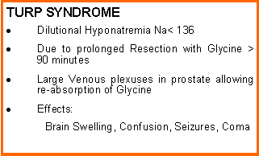

Why is it done?

• This procedure is performed when the prostate gland is enlarged to such an extent that medication cannot relieve the urinary symptoms.
• Symptoms include: a weak stream, nightly urination, frequent urination, inability to urinate, (LUTS) kidney failure due to the obstruction, bladder stones, recurrent bladder infections.
• Medication such as Flomaxtra, Urorec Minipress etc. should always be given as a first resort.
• Step-up therapy should have been used for prostates larger than 35-50cc with either Duodart, Avodart or Proscar
• Prostate cancer first needs to be ruled out by doing a PSA, and when indicated, with a 3T MRI scan of the prostate with an abnormal PSA with a possible prostate biopsy of any suspicious lesions.
• A TURP can also be performed to dis-obstruct a severe prostate cancer, to allow a normal urination process.

. 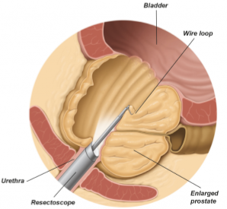

How is it done?

• patients will receive a general anaesthesia, unless contra-indicated.
• A cystoscopy is performed by placing a camera in the urethra with the help of a lubricant jelly and an irrigant fluid.
• The inside of the bladder is viewed for pathology. If any suspicious lesions are seen, a biopsy will be taken.
• A resection of the prostate is then started and should take 60-90 minutes.
• Prophylactic antibiotics will be given to prevent any infections.

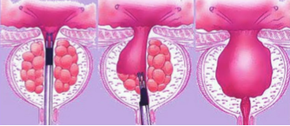

.

Complications

Side–effects

• Retrograde ejaculation in more than 90% of patients. Therefore if you have not completed your family, this procedure is not for you unless absolutely necessary.
• Infertility as a result of the retrograde ejaculation.
• Stress incontinence especially in the elderly and the diabetic patients
• Patients with Multiple Sclerosis, Strokes and Parkinsons have a higher risk of incontinence and risks should be discussed and accepted prior to surgery.
• Urethral structuring in 2-3% of patients, requiring intermittent self-dilatation.
• Regrowth of prostate lobes within 3-5 years requiring a second procedure.
NB! Each person is unique and for this reason symptoms vary

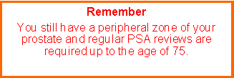

Copyright 2019 Dr Jo Schoeman

