Trans Rectal Ultrasound Guided Prostate Biopsies/ Saturation TRUS biopsies

Item Number: 37219, 55603

You would have had a 3T MRI study prior to pin point any suspicious high grade lesions. Usually targeted biopsies are taken of the prostate via the rectum.
The 3 possibilities of an elevated PSA is:
• Benign Prostate Hyperplasia,
• Prostatitis or
• Prostate Cancer.

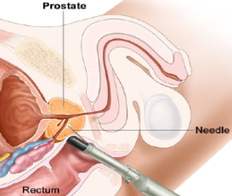

Why is it done?

• This is diagnostic procedure used to make a diagnosis for an elevated PSA.
• It is done as a day surgery procedure. You are required to remain starved 6-8 hours prior to the procedure.

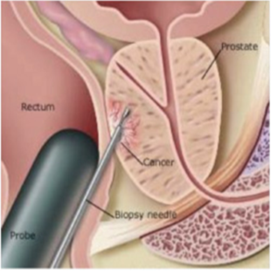
.

How is it done?

• This procedure: is done under sedation as a day procedure and takes approximately 30min (Incl anaesthetic time)
• It is performed with the patient lying in the fetal position on his left side.
• Prophylactic antibiotics are essential and a script with details are provided on the day of signing consent. You will start the Ciprofloxacin 500mg the night before the procedure, with the next dose the morning of the procedure with a small sip of water. X 2 days

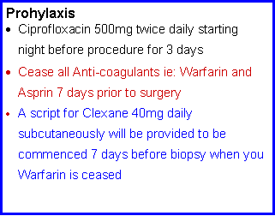
.

Complications

Side–effects

• Haematuria (blood in urine) 2-3days
• Haematospermia ( blood in ejaculate) will become less the more often you ejaculate.
• Bacteraemia (infection) with low grade fever and feeling un-well
• Bood in stools
• Sepsis with high grade fever, cold shivers, rigors
REQUIRES URGENT ATTENTION

Copyright 2019 Dr Jo Schoeman

