Trans Perineal Ultrasound Guided Placement of Fudicial Markers

Item Number: 37217, 55603

You would have received a diagnosis of Prostate Cancer and Radiation Therapy would have been discussed as the most appropriate treatment for the stage and specifics of your cancer.

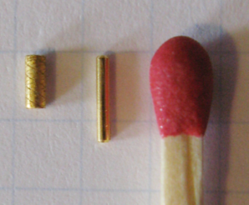

Why is it done?

• This is the placement of gold seed markers in the prostate to assist with radiation. This is to identify the edges of the prostate as it shrinks with Hormonal Therapy and the effects of Radiation Therapy
• It is done as a day surgery procedure. You are required to remain starved 6-8 hours prior to the procedure.
• You would have had a diagnosis of a locally advanced prostate cancer with no metastatic disease being present. The seed placement assists in localizing the prostate borders during radiation .

.

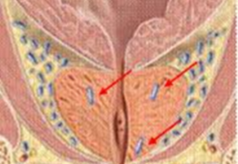
.

How is it done?

• This procedure: is done under GA as a day procedure and takes approximately 30min (Incl anaesthetic time)
• It is performed with the patient lying on your back with legs in lithotomy
• Antibiotics are given on the table prior to the procedure

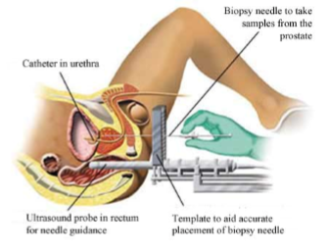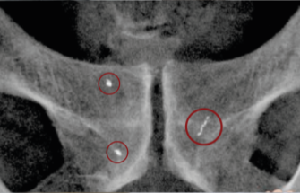

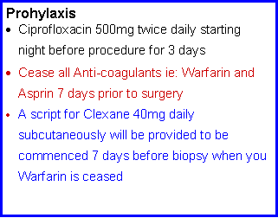
.

Complications

Side–effects

• Haematuria (blood in urine) 2-3days
• Haematospermia ( blood in ejaculate) will become less the more often you ejaculate.
• Bacteraemia (infection) with low-grade fever and feeling un-well
• Sepsis with high grade fever, cold shivers, rigors REQUIRES URGENT ATTENTION

Copyright 2019 Dr Jo Schoeman

