MRI-Ultrasound fusion
Transperineal Prostate Biopsies

Item Number: 37219, 55603

MRI targeted biopsies of a suspicious lesion in prostate found on MRI investigations

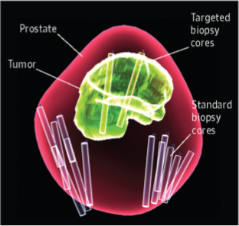

Why is it done?

• This is diagnostic procedure used to make a diagnosis for an elevated PSA.
• It is done as a day surgery procedure. You are required to remain starved 6-8 hours prior to the procedure.
• This technique allows for minimal, accurate, targeted biopsy of a suspicious nodule
• Transperineal technique allows for almost 0% sepsis rate

You would have had a 3T MRI study prior to pin point any suspicious high grade lesions. The MRI image is then fused with the UroNav software to enable accurate biopsies
The 3 possibilities of an elevated PSA is:
• Benign Prostate Hyperplasia,
• Prostatitis or
• Prostate Cancer.

Saturation biopsies include numerous biopsies and are generally recommended for second/third time biopsies.

. 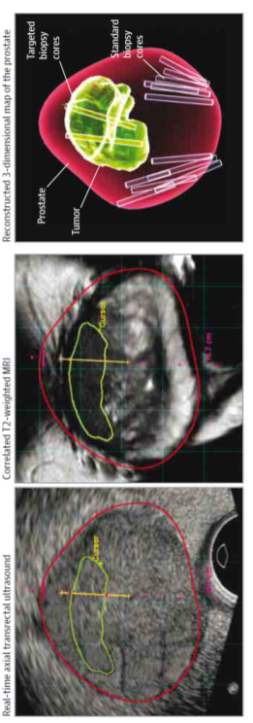

How is it done?

• This procedure: is done under GA as a day procedure and takes approximately 60min (Incl anaesthetic time)
• It is performed with the patient lying in the lithotomy position.
• Rectal ultrasound probe placed
• Sterile preparation of the perineum usually with Betadine
• MRI images are fused with ultrasound images and the target lesion identified

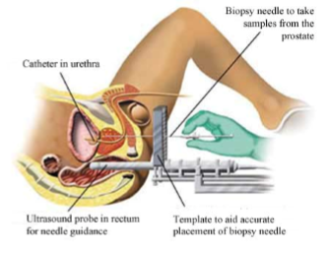

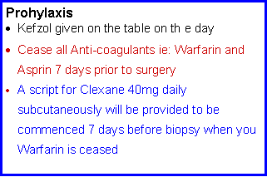
.

Complications

Side–effects

• Haematuria (blood in urine) 2-3days
• Haematospermia ( blood in ejaculate) will become less the more often you ejaculate.
• Bacteraemia (infection) with low grade fever and feeling un-well < 1%
REQUIRES URGENT ATTENTION

Copyright 2019 Dr Jo Schoeman

