Excision of Spermatocoele/ Epididymal Cyst

Item Number: 37623, 18262

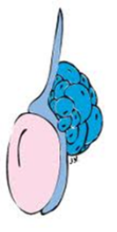

Why is it done?

• Enlarged scrotum
• Could be uncomfortable
• The cyst can become so big that the enlarged scrotum buries the penis making usual functions difficult, ie urination and sexual function
• May contribute to Infertility

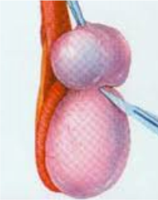

How is it done?

• This procedure is done under general anaesthetic.

• Supine position.

• The penis and scrotum is surgically prepared with Betadine

• A midline scrotal incision is done.

• The intact spermatocoele/epididymal cyst with the testis is delivered through the skin incision.

• The epididymocoele is carefully surgical resected off the spermatic cord or epididymus.

• A hemostatic running suture is placed around the raw edge of resection, if required

• Hemostasis is actively chased.

• A drain is left overnight.

• An Indwelling catheter is left for 6-8 hours to prevent acute urinary retention.

• The scrotum is closed in 2 layers with dissolvable sutures.

• You would be required to bring 2 pairs of tight new undies for post-operative scrotal support, these will be placed post-operatively

. 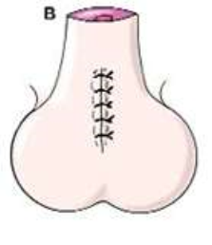
.

Complications

Side–effects

• Any anaesthetic has its risks and the anaesthetist will explain such risks.
• Bleeding is a possible complication therefore the scrotal drain/s overnight.
• Your catheter will be removed the next
• You will have scrotal swelling and bruising for the next 2-6 weeks
• Any sudden increased swelling needs urgent attention!
• Any symptoms of fever and signs of infection, requires urgent attention!

Copyright 2019 Dr Jo Schoeman

