Vault Repair (Sacro-Colpo Pexy)

**Item Number:**

**Prolapse of the Vault of the Vagina**

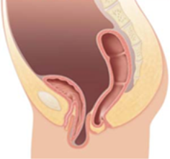

Why is it done?

• The aim of surgery is to relieve the symptoms of vaginal bulge and/or laxity

• Improve bladder function without interfering with sexual function

• Used where own natural tissue is too weak to use

• Vaginal prolapse is a common condition causing symptoms such as a sensation of dragging or fullness in the vagina, and difficulty emptying the bowel or bladder and back ache.

• About 1 in 10 women need surgery for prolapse of the uterus or vagina.

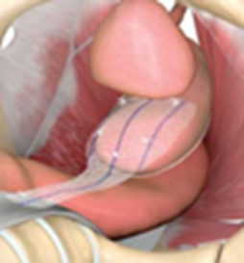

How is it done?

• This procedure is done under a general anaesthetic.

• Sacrocolpopexy is performed either through an abdominal incision or ‘keyholes’ (using a laparoscope or Robotic-assisted)

• The vagina is first freed from the bladder at the front and the rectum at the back.

• A graft made of permanent synthetic mesh is used to cover the front and the back surfaces of the vagina.

• The mesh is then attached to the sacrum (tail bone)

• The mesh is then covered by a layer of peritoneum that lines the abdominal cavity; this prevents the bowel from getting stuck to the mesh.

• Sacrocolpopexy can be performed at the same time as surgery for incontinence or vaginal repair for bladder or bowel prolapse.

• A pelvic drain is left post-operatively

• A cystoscopy may be performed to confirm that the appearance inside the bladder is normal and that no injury to the bladder or ureters has occurred during surgery.

• A pack may be placed into the vagina and a catheter into the bladder at the end of surgery.

• If so, this is usually removed after 3-48 hours. The pack acts like a compression bandage to reduce vaginal bleeding and bruising after surgery.

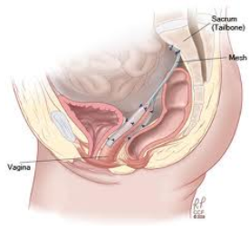

Complications

• Pain (generally or during intercourse) in 2-3%

• Exposure of the mesh in the vagina in 2-3%

• Damage to bladder, bowel or ureters in 1-2%

• There are also general risks associated with surgery:

Wound infection,

Urinary tract infection,

Bleeding requiring a blood transfusion and

Deep vein thrombosis (clots) in the legs,

Chest infection

.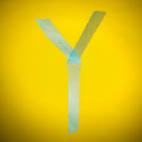 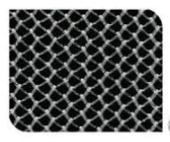

Copyright 2019 Dr Jo Schoeman

