Urethral Stent
UROLUME

Item Number:

Minimal invasive management for the relief of LUTS (lower urinary tract symptoms) or Urinary Retention caused by an Urethral Stricture

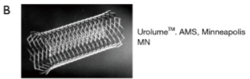

Why is it done?

• This procedure is performed when concentric scarring in the urethra causes LUTS and /or Urinary Retention
• Symptoms include: a weak stream, nightly urination, frequent urination, inability to urinate, (LUTS) and Urinary Retention
• This is alternative to an invasive procedure where long periods of anaesthetic is contra-indicated.
• Usually for chronically sick patients who cannot undergo surgery, yet are active enough not to want a permanent catheter.
• Patients who don’t want to / cannot do intermittent self-dilatation of these strictures
• Don’t want a permanent Indwelling Catheter

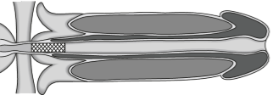

How is it done?

• Patients will receive a sedation with local anaesthetic gel placed in the urethra.
• A cystoscopy is performed by placing a camera in the urethra with the help of a lubricant jelly and an irrigant (fluid).
• The measurements of the urethral is taken (length)
• Appropriate length coil is chosen.
• The device is placed through the cystoscopic sheath, to sit snug in the prostate urethra stretching over the length of the stricture
• Prophylactic antibiotics will be given to prevent any infections.

. 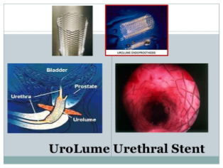

Complications

Side–effects

• Persistent pain in penile shaft
• Pain in Perineum when seated
• Migration of the device
• Erosion of device
• Possible infection
• Long term yields the risk for encrustation and recurrent infections
• NB! Each person is unique and for this reason symptoms vary!

Copyright 2019 Dr Jo Schoeman

