Excision of Urethral Diverticulum – Female

Item Number:

Why is it done?

• Usually an infected peri-urethral gland blocks and becomes infected
• Causes a bulge which interferes with urination
• Can mimic a vaginal prolapse
• Usually an MRI of the urethra delineates this beautifully.

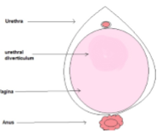

How is it done?

• This procedure is done under a general anaesthetic, as decided by the anaesthetist.
• The legs will be elevated into the lithotomy position.
• This procedure is done both cystoscopically and with an incision over the urethra.
• The urethra is evaluated. endoscopically and a catheter placed
• The vaginal mucosa will then be incised over the urethrocoele.
• A Fogarty catheter will be placed inside the diverticulum and the balloon inflated to delineate the borders of the diverticulum.
• The diverticulum will be dissected out with injuring adjacent structures.
• The neck will be tied off at the level of the adjoining urethra.
• Dissolvable vaginal closure sutures will be placed for hemostasis
• A cystoscopy confirms no injury to the urethra.
• A catheter will be placed until you are awake for some compression.
• Prophylactic antibiotics will be given to prevent infection.

. 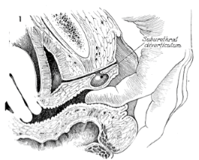
.

Complications

Side–effects

• Any anaesthetic has its risks and the anaesthetist will explain all such risks.
• Complications: hemorrhaging, and urine retention
• Patients catheter will be removed the next morning
• If you cannot urinate after 2-3 attempts, a catheter may be inserted to empty your bladder.
• You may suffer temporary incontinence
• You may suffer permanent incontinence as advised by Jo, depending on the extent of the diverticulum. Make sure you have discussed this with Jo.
NB! Each person is unique and for this reason symptoms may vary

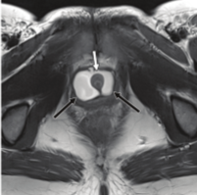
Copyright 2019 Dr Jo Schoeman

