Exision of Urethral Caruncle
Prolapsed Urethral Mucosa

Item Number:

Why is it done?

• Prolapsed urethral mucosa causing pain and bleeding
• Occurs from childhood to old age

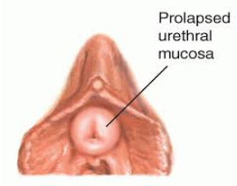

How is it done?

• This procedure is done under a spinal / general anaesthetic, as decided by the anaesthetist.
• The legs will be elevated into the lithotomy position. (stirrups)
• This procedure is done with cystoscopy.
• Your bladder and urethra is inspected with cystoscopy
• The prolapsed mucosa will then be excised at the external meatus.
• Dissolvable sutures will be placed for hemostasis
• A catheter will be placed until you are awake for some compression.
• Prophylactic antibiotics will be given to prevent infection.

. 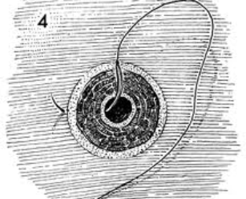 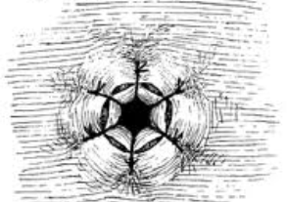
.

Complications

Side–effects

• Any anaesthetic has its risks and the anaesthetist will explain all such risks.
• Complications: hemorrhaging, and urine retention
• Patients catheter will be removed the next morning.
• If you cannot urinate after 2-3 attempts, a catheter may be inserted to empty your bladder.
• You may be required to keep the catheter for a few days if you have persistent bleeding or urinary retention.
• NB! Each person is unique and for this reason symptoms may vary!

Copyright 2019 Dr Jo Schoeman

