Second Stage
Sacro Neuro Modulation

Item Number: 36666, 18262

When the Temporary leads for SNM has proven to have given an improvement in symptoms a permanent lead placement is done
The aim was to alter the neuro-transmission from the Spinal Centre to the Bladder:

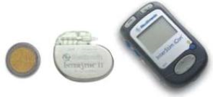

Why is it done?

• To alter the neuro-transmission from the Spinal Centre to the Bladder:
• Refractory Over Active Bladders with Urge Incontinence .
• Under Active Bladders
• Chronic Pelvic Pain
• Faecal Incontinence
• Causative factors:
Undetermined
Neurogenic causes such as Multiple Sclerosis

When at least 2 anticholinergic drugs or B-adrenergic drugs have failed to have provide an improvement in symptoms of OAB
An alternative for ISC or permanent IDC for UAB
The aim was to alter the neuro-transmission from the Spinal Centre to the Bladder
This initial 2 week trial would have provided > 50% improvement in urinary symptoms

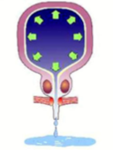

How is it done?

• A sedation or GA is administered with local anaesthetic
• You will be placed prone (on your stomach) with lower back and buttocks exposed
• The tined lead that has been placed in the S3 foramina of the sacrum has been connected to a an external battery
• The external lead connection will be removed and a larger pocket will be made for the permanent subcutaneous battery and connection
• Subcutaneous sutures will be placed, which will dissolve.

. 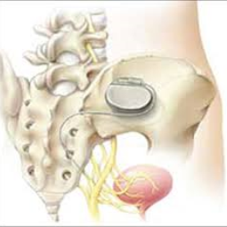

Complications

• Some local discomfort may be experienced.
• Nerve stimulator may provide abnormal sensations, which your body adjusts to.
• A Representative from Medtronic will be in contact with you to check on your settings and responses.
• NB! Each person is unique and for this reason symptoms may vary!

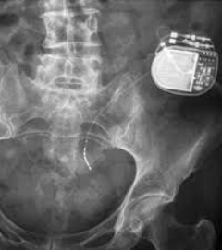

Copyright 2019 Dr Jo Schoeman

