Full implant
Sacro Neuro Modulation

Item Number: 36666, 36663, 18262

The aim is to alter the neuro-transmission from the Spinal Centre to the Bladder

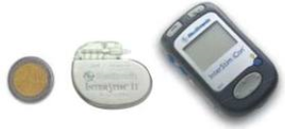

Why is it done?

· Incomplete Bladder emptying, large post void residual urine volumes
· Under Active Bladders
· Chronic Pelvic Pain
· Causative factors:
Undetermined
Neurogenic causes such as Multiple Sclerosis,
Diabetes

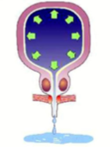

How is it done?

• A sedation is administered with local anaesthetic
• You will be placed prone (on your stomach) with lower back and buttocks exposed
• The tined lead will be placed in the S3 foramina of the sacrum under imaging
• The lead will be tunneled under the skin and connected to an Internal Battery
• A pocket will be made for the permanent subcutaneous battery and connection
• Subcutaneous sutures will be placed, which will dissolve.

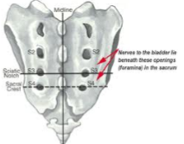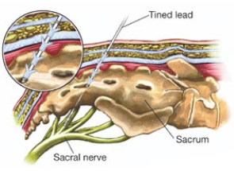

Complications

• Some local discomfort may be experienced.
• Nerve stimulator may provide abnormal sensations, which your body adjusts to.
• A Representative from Medtronic will be in contact with you to check on your settings and responses.
• A review at SAWMH with Medtronics will be scheduled at 3 months, to confirm that the device is functioning optimally
• Further review appointments will be scheduled as required
• The battery should last between 7-10 years
• NB! Each person is unique and for this reason symptoms may vary!

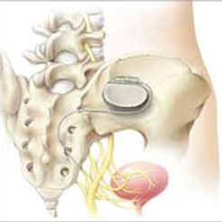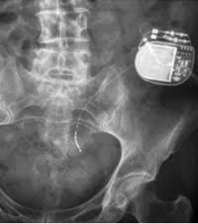

Copyright 2019 Dr Jo Schoeman

