Perineostomy – Perineal Urostomy

Item Number:

Opening of the posterior Urethra on the Perineum

Why is it done?

• Seldom done
• This procedure is performed when concentric extensive scarring in the urethra (strictures) causes Urinary Retention
• Long history of strictures.
• This is alternative to an invasive procedure where long periods of anaesthetic is contra-indicated and exstensive grafts may be required
• Usually for chronically sick patients who cannot under go surgery, yet are active enough not to want a permanent catheter.
• Patients who don’t want to / cannot do intermittent self-dilatation of these strictures
• Don’t want a permanent Indwelling Catheter penile/Urethral cripple

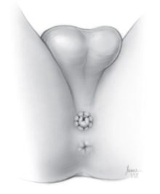

How is it done?

• Patients will receive a General Anaesthetic.
• A Flexible cystoscopy is done through your urethra or suprapubic catheter site to find normal urethra (usually posterior urethra)
• A urethral sound is placed/ catheter
• A perineal incision is made.
• Urethra is divided proximal (above) the stricture
• The opening of the urethra is brought out snd attached to the skin on the perineum (area between scrotum and anus)
• A catheter is placed
• Prophylactic antibiotics will be given to prevent any infections.

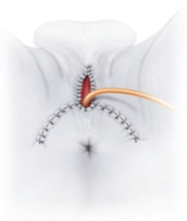

Complications

• Persistent pain in penile shaft
• Pain in Perineum when seated
• Scarring of the opening requiring dilatation
• Possible infection
• NB! Each person is unique and for this reason symptoms vary!

Copyright 2019 Dr Jo Schoeman

