Frenuloplasty

Item Number:

• Penile tip has a ventral curvature with erection
• Frenulum can tear and bleed with intercourse

Why is it done?

• To straighten out a curved penis pulled ventrally by a tight frenulum

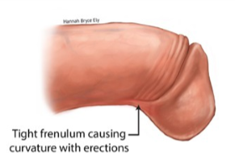

How is it done?

• This is done under general anaesthesic or a penile block.

• A horizontal cut is made through the tightest part of the frenulum

• The incision is then closed by opposing edges in the vertical plane .

• Dissolvable sutures are placed between the 2 remaining edges.
A local anaesthetic is injected into the base of the penis thus giving post-operative pain relief for the next 4-6 hours

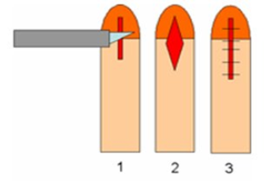

Complications

• Any anaesthetic has its risks and the anaesthetist will explain such risks.
• Bleeding is a common complication.
• With any subsequent erections post operatively, the sutures may pull out causing an opening of the wound with subsequent bleeding.
• An infection of the wound can occur
NB! Each person is unique and for this reason symptoms may vary
.

Copyright 2019 Dr Jo Schoeman

