Laparoscopic Nephropexy

Item Number: 36537

Why is it done?

• Nephroptosis causing abdominal pain
• Confirmed on standing Urogram with hydronephrosis caused by kinking of ureter as the kidney falls down due to loss of supporting structures

Very Important!!
The correct side for surgery should be checked : CT scan present
Your approval Prior to anaesthesia being commenced

How is it done?

• GA
• Prophylactic anti-biotics is given.
• An indwelling catheter is placed.
• The correct kidney is identified and marked while you are awake
• Depending on the affected side of 3-4 incisions will be made and a hand port
• The colon is reflected to reveal the retro-peritoneal space
• The ureter is identified and cleared up to the hilum
• The upper pole of the kidney is mobilized with its surrounding fat.
• A proximal spot on the psoas muscle is cleared
• 2 Non-dissolvable sutures are used to fix the upper pole of the kidney to the Psoas Muscle
• A drain is placed
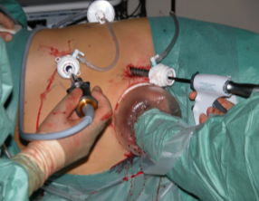

.

Complications

Side–effects

• Minimal Blood loss
• Wound Infection.
• Post-operative hernia formations especially associated in the elderly with atrophic abdominal muscles
• Prolonged hospital stay due to impaired renal function recovery.
• Dialysis as discussed by your Nephrologist, if pre-operatively indicated
NB! Each person is unique and for this reason symptoms vary

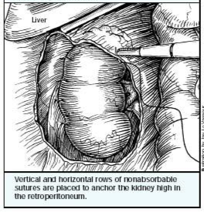
Copyright 2019 Dr Jo Schoeman

