NanoKnife Focal Therapy for
Prostate Cancer

Item Number: No Item Number, not covered by Medicare / Healthfund

What is IRE
• Irreversible Electroporation Therapy—breaking up of cell membranes using electric current by means of creating holes in the cell walls (Nano-pores)
• Non-thermal ablation

Why is it done?

• Treatment for localized Superficial Urothelial Carcinoma of Bladder and Ureter

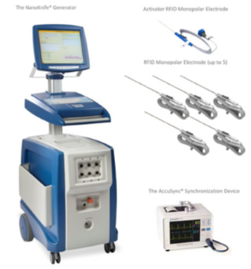

How is it done?

• Focal therapy of prostate cancer, usually a single lesion
• Preferably Gleason 3,4
• Preserving prostate supporting tissue and erectile function and continence

You would have had a 3T MRI study possibly a PET PSMA as well prior to confirm your prostate cancer. Usually whole gland biopsies are taken of the prostate via the perineum to prove uni-focal cancer.
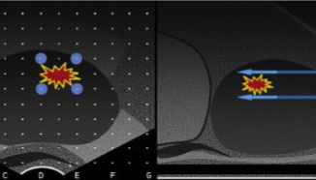

• This procedure is done under general anaesthesia as a day procedure and takes approximately 60-90min (Incl anaesthetic time)
• It is performed with the patient lying in lithotomy (legs in stirrups) position
• Prophylactic antibiotics are essential and a script with details are provided on the day of signing consent. You will start the Ciprofloxacin 500mg the night before the procedure, with the next dose the morning of the procedure with a small sip of water X 2days
• A trans-rectal ultrasound is placed
• 4-5 NanoKnife electrodes are paced approximately 2cm apart surround the focal cancer.
• Electrical current of 3A is run at 800-1331mcs pulse causing a non-thermal ablative technique
• Total treatment as soon as electrodes are placed is < 5 minutes
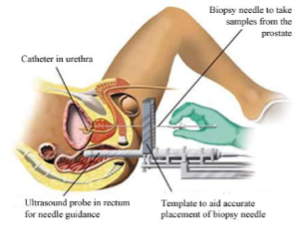

What next?

• Hematuria (blood in urine) 2-3days
• Hematospermia ( blood in ejaculate) will become less the more often your ejaculate.
• Bacteraemia (infection) with low grade fever and feeling un-well
• Perineal hematoma
• Perineal pain and penis tip pain
• Prostate swelling causing bladder outlet obstruction requiring a catheter for up to 5 days
ANY FEVER REQUIRES URGENT ATTENTION

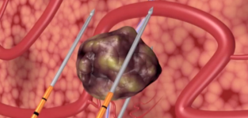
.

Complications

Side–effects

• You will be discharged with an indwelling catheter for 3-5days depending on the size of your prostate and the lesion treated
• You may have necrotic tissue developing requiring a resection (treatment involving the urethra).
• Difficulty in urination up to 6 weeks after the procedure
• It could feel like you are sitting on an golf ball for a week

Phone my rooms the day before the procedure to check your expected times for the following day.

You are to continue your antibiotics for the next 10 days.

Should there be any signs of fever or cold shivers, you are to return to the Hospital or Emergency Department without hesitation

Copyright 2019 Dr Jo Schoeman

