Intravesical iAluRil-Therapy

Item Number:

Why is it done?

• New long awaited treatment for Advanced or Resistant Painful Bladder Syndrome or “Interstitial Cystitis”

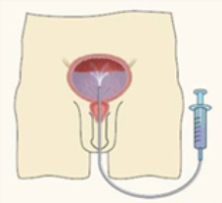

How is it done?

• A Local anaesthetic gel is administered as for a Urethral Catheterisation procedure
• This is done under sterile procedure.
• A 14-16 Fr Indwelling Catheter is placed into your bladder.
• The i-AluRil is installed using strict administering criteria
• Usually 1 vial of i-AluRil will be pre-mixed and instilled in your bladder
• The catheter is then removed
• The i-AluRil is required to stay in your bladder for 15 –30 minutes
• This bladder distention could be painful
• WARNING: Any Fevers require urgent attention
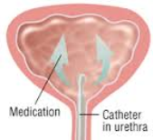

What next?

• Some local discomfort may be experienced.
• Your voiding nature will change within the next week
• You may experience some improvement in Chronic Bladder Pain
• You may hopefully experience longer time interval between urination
• Delayed effects would be a urinary tract infection
• NB! Each person is unique and for this reason symptoms may vary!

. 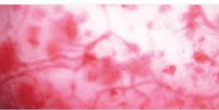

Complications

Side–effects

• This will be done every week for 4 weeks then fortnightly for the next month
• Maintenance Protocol may be instituted
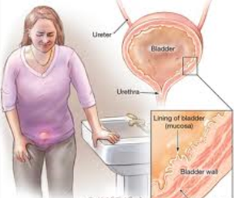
Copyright 2019 Dr Jo Schoeman

