Intravesical Mitomycin C –Therapy

Item Number:

Why is it done?

• Treatment for localized Superficial Urothelial Carcinoma of Bladder and Ureter

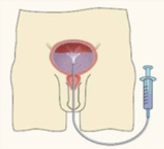

How is it done?

• A Local anaesthetic gel is administered as for a Urethral Catheterisation procedure
• This is done under sterile procedure.
• A 14-16 Fr Indwelling Catheter is placed into your bladder.
• The pre-made-up Mitomycin solution is installed using strict administering criteria
• Usually 2 vials of 20mg MMC is mixed with Saline to a 50cc volume. You require 40mg.
• The catheter is then removed
• The MMC is required to stay in your bladder for 1 hours.
• Body rotation is not required.
• WARNING: Any Fevers require urgent attention

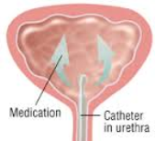

What next?

• Some local discomfort may be experienced.
• Your voiding nature will change within the next week
• You may experience some urinary frequency
• You could developed a fever requiring urgent attention.
• Some patients may experience severe pain when/ if the tumour was resected very deep.
NB! Each person is unique and for this reason symptoms may vary

.

Complications

Side–effects

• This will be done every week for 6 weeks
• 6 weeks after this a check Flexible Cystoscopy will be scheduled as part of your surveillance protocol for your Urothelial carcinoma
• This may be repeated.
Surveillance Protocol for Superficial Urothelial Carcinoma

Low Grade: Ta, T1 (G1, G2) , CIS
• Initially 3 months after first resection
• If clear then 9months
• Then annually

High Risk Low Grade: T1G3 with/out CIS, high volume disease
• This disease may be best treated with a Radical cystectomy
• 3 monthly Check Cystsocopy for 12 months
• If clear, then 6 monthly for a further 12 months
• If clear then annually for 5-7 years
• My recommendation thereafter would be a 2-yearly cystoscopy with intermittent Urine Cytology
• You fall back to the beginning with any recurrences
• Please don’t hesitate to direct all further queries to Dr Schoeman’s rooms.

Copyright 2019 Dr Jo Schoeman

