Intravesical Chorpactin Therapy

Item Number:

Why is it done?

• Treatment for Advanced or Resistant Painful Bladder Syndrome or “Interstitial Cystitis”

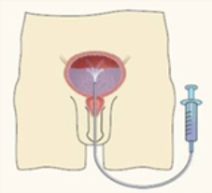

How is it done?

• A Local anaesthetic gel is administered as for a Urethral Catheterization procedure
• This is done under sterile procedure.
• A 14-16 Fr Indwelling Catheter is placed into your bladder.
• The DMSO is installed using strict administering criteria
• Usually 1 vial of DMSO will be pre-mixed with Saline to a 50cc volume by a Compound Pharmacist
• The catheter is then removed
• The DMSO is required to stay in your bladder for 15 minutes
• This bladder distention could be painful
• WARNING: Any Fevers require urgent attention

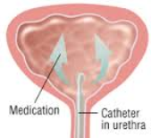

What next?

• Some local discomfort may be experienced.
• Your voiding nature will change within the next week
• You may experience some improvement in Chronic Bladder Pain
• You may hopefully experience longer time interval between urinarion
• Delayed effects would be a urinary tract infection
• NB! Each person is unique and for this reason symptoms may vary!

. 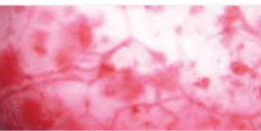

Complications

Side–effects

• You will empty your bladder and the content will be discarded
• You may have a garlick-like odour about you

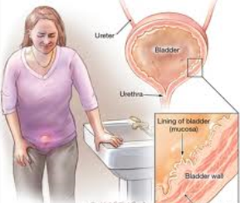
Copyright 2019 Dr Jo Schoeman

