Intravesical Chorpactin Therapy

Item Number:

Why is it done?

• Treatment for Advanced or Resistant Painful Bladder Syndrome or “Interstitial Cystitis”
• Only 1% of Urologist use this as last resort for PBS/IC

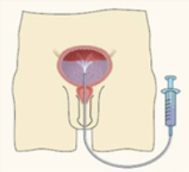

How is it done?

• This is done under sedation using sterile procedure.
• A 14-16 Fr Indwelling Catheter is placed into your bladder.
• The Chlorpactin is installed using strict administering criteria
• Usually 1 vial of 1-2% will be pre-mixed with Saline to a 50cc volume by a Compound Pharmacist
• This is kept in the bladder for a few minutes and repeated 3 times
• This bladder distention could be painful
• WARNING: Any Fevers require urgent attention

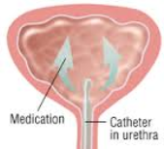

What next?

• Intense local discomfort may be experienced.
• Your voiding nature will change within the next week
• You may experience some improvement in Chronic Bladder Pain
• You may hopefully experience longer time interval between urination
• Delayed effects would be a urinary tract infection
• NB! Each person is unique and for this reason symptoms may vary!

. 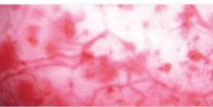

Complications

Side–effects

• Some local discomfort may be experienced.
• Your voiding nature will change within the next week
• You may experience some urinary frequency
• You could developed a fever requiring urgent attention.
• Delayed effects would a urinary tract infection
• NB! Each person is unique and for this reason symptoms may vary!
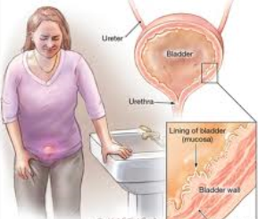
Copyright 2019 Dr Jo Schoeman

