Flexible Cystoscopy& Urethral Dilatation

Item Number: 36833

A day procedure under local anaesthetic, where a flexible cystoscope is placed in the bladder via the urethra to remove a stent placed with previous upper tract work

Why is it done?

To investigate:
• Haematuria (blood in the urine)
• Recurrent urinary tract infections
• Dilatation of Urethral narrowing/ stricture
• Abnormal cells suggestive of urothelial carcinoma, on urine cytology

Risk factors for strictures:
• Straddle injuries
• Catheterisation or urethral instrumentation
• Infections
• Bypass cardiac surgery

How is it done?

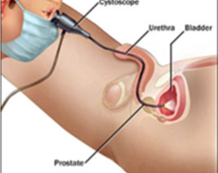

• A cystoscopy is performed by placing a camera in the urethra with the help of a lubricant jelly and saline
• The bladder is then distended using the fluid

Urethral Dilatation
• If you have a urethral stricture, a guidewire will be placed and the narrowing dilated
• There may be some hemorrhaging and you may need a catheter for 3 days
• This will be removed at the hospital in 3 days or alternatively arrange for your GP to remove.
• I will review in 6 –8 weeks

Antibiotics may be given to prevent infection
.

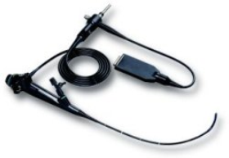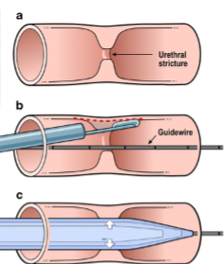

Complications

What to expect after the procedure?
• You may be sent home with an indwelling catheter for 3 days
• Pain on initial passing of urine after it is removed
• Bladder infection ranging from a burning sensation to, fever, to puss (rare)
• Blood stained urine
• Lower abdominal discomfort which will persist for a few days
• NB! Each person is unique and for this reason symptoms vary.
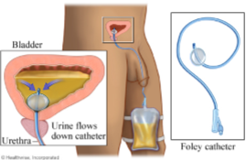

Copyright 2019 Dr Jo Schoeman

