Flexible Cystoscopy& Removal Stent

Item Number: 36833

A day procedure under local anaesthetic, where a flexible cystoscope is placed in the bladder via the urethra to remove a stent placed with previous upper tract work

Why is it done?

To investigate:
• Haematuria (blood in the urine)
• Recurrent urinary tract infections
• Space occupying lesions in the kidneys, ureters and bladder investigated with ureteroscopy
• Abnormal cells suggestive of urothelial carcinoma, on urine cytology
• Removal of stent

Risk factors:
• Strong family history of bladder cancer
• Smokers or passive smokers
• Factory workers: dyes, paints, etc
• Renal stone disease, bladder stones with recent surgery resulting placement of stent

How is it done?

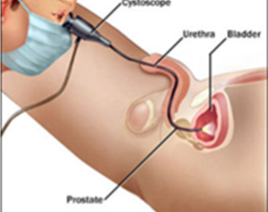

• A cystoscopy is performed by placing a camera in the urethra with the help of a lubricant jelly and saline
• The bladder is then distended using the fluid
• The inside of the bladder is viewed for pathology.
• If any suspicious lesions are seen, a biopsy will be taken.
• Urine would have been sent for cytology prior to the procedure, to rule out the existence of cancer.
• Antibiotics may be given to prevent infection.

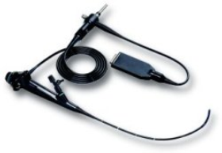

Complications

What to expect after the procedure?
• Pain on initial passing of urine
• Bladder infection ranging from a burning sensation to, fever, to puss (rare)
• Blood stained urine
• Lower abdominal discomfort which will persist for a few days
• NB! Each person is unique and for this reason symptoms vary.

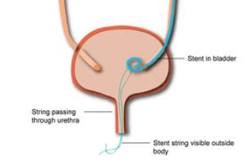

Indications for a Ureteric stent
• Hematuria from upper tracts
• Disobstruction of the ureter caused either calculus, blood clot or tumour
• External compression of the ureter by retro-peritoneal pathology ie: Fibrosis, retroperitoneal lymphnode compression
• Reduced renal function associated with hydronephrosis
• Sepsis associated with hydronephrosis

Copyright 2019 Dr Jo Schoeman

