Trans-urethral cauterization of bladder bleeders + Evacuation Clots

Item Number:

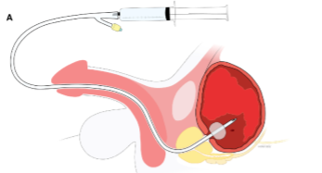

Why is it done?

Primary management of:
• Continuous or intermittent bleeding from bladder vessels
• More prominent after radiation therapy with neo-vascularisation
• Induced or aggravated by blood thinning and anti-platelet therapy

Risk factors:
• Anti-coagulation therapy : Warfarin, Xaralto etc
• Anti-platelet therapy
• Radiation to bladder prostate or bowel
• These need to be stopped prior to the procedure

How is it done?

• This is done under General anaesthesia.
• A cystoscopy is performed by placing a camera in the urethra with the help of a lubricant gel and saline irrigation.
• The bladder is then distended with saline.
• A resectoscope is then placed.
• I use Bi-polar resection, thus using Saline as irrigation.
• The vessels are cauterized and sealed
• A 3 way catheter is placed with continuous saline irrigation until your urine is clear
• Antibiotics may be given to prevent infection.

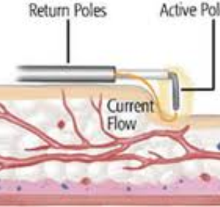

.

Complications

Side–effects

• You may have a 22 –24 French (thick) 3 way urethral catheter placed through your urethra.
• It does have a channel for placement of constant saline irrigation and another for the drainage of the blood-stained urine.

• The Continuous bladder irrigation will continue until your urine is clear approximately 24-48hrs.

• This can also be remedied by drinking plenty of fluids until it clears.

• As soon as the colour of your urine is satisfactory, your catheter will be removed.

Copyright 2019 Dr Jo Schoeman

