Urolift

Item Number:

Minimal invasive management for the relief of LUTS (lower urinary tract symptoms)

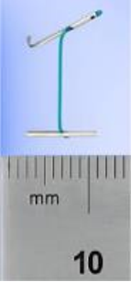

Why is it done?

• This procedure is performed when the prostate gland is causing LUTS and you want an alternative to medication without the complications of a permanent procedure.
• Symptoms include: a weak stream, nightly urination, frequent urination, inability to urinate, (LUTS) kidney failure due to the obstruction, bladder stones, recurrent bladder infections.
• Medication such as Flomaxtra, Urorec, Minipress etc. should always be given as a first resort.
• This is alternative to medication where ejaculatory function is to be preserved.
• Prostate cancer first needs to be ruled out by doing a PSA, and when indicated, with a 3T MRI scan of the prostate with an abnormal PSA with a possible prostate biopsy of any suspicious lesions.
• Usually a trial of alpha blockers would been attempted
• Prostate sizes up to 80-100 cc with NO midlobe.

How is it done?

• Patients will receive a general anaesthesia, unless contra-indicated.
• A cystoscopy is performed by placing a camera in the urethra with the help of a lubricant jelly and an irrigant fluid.
• The inside of the bladder is viewed for pathology. If any suspicious lesions are seen, a biopsy will be taken.
• The device is placed through the cystoscopic sheath.
• Prostate lobes are drawn apart similar to opening a curtain.
• Occasionally a Bladder Neck Incision may be done if the bladder neck is too narrow.
• Prophylactic antibiotics will be given to prevent any infections.

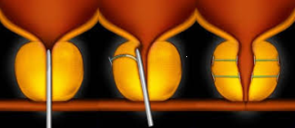
.

Complications

Side–effects

• Ejaculation will not be affected as with medication, TURP and TUVP, therefore no retrograde ejaculation, thus preserving sexual function
• Fertility is no guaranteed. If it is an issue, DON’T DO IT!.
• No Stress incontinence especially in the elderly and the diabetic patients
• May experience a slower stream initially due to swelling
• Some urgency symptoms
• Possible infection due to cystoscopy (<2%)
• Rare cases of stone formation on clips.
• Further enlargement of prostate lobes within 3-5 years requiring a definite procedure.
• NB! Each person is unique and for this reason symptoms vary!

Copyright 2019 Dr Jo Schoeman

