Optic Urethrotomy

Item Number: 37327

Why is it done?

• To treat a narrowing in the urethra which has formed due to previous damage/injury to the urethra.
• Causes: after bypass surgery where a drop in blood pressure has caused an area of low blood supply to the urethra; trauma to the urethra (pelvic fractures/ urethral instrumentation); and sexually transmitted diseases.
• The procedure entails cutting the stricture with a cold knife.
• It also prevents eventual kidney damage/failure.

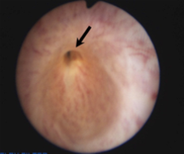

How is it done?

• A urethroscopy is performed by placing a camera in the urethra, with the help of a lubricant jelly and an irrigant fluid, to identify the stricture.
• A cold knife is then used to cut the stricture open.
• The inside of the bladder is viewed for pathology.
• If any suspicious lesions are seen, a biopsy will be taken.
• Prophylactic antibiotics may be given to prevent infection.
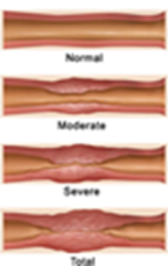

.

Complications

Side–effects

• Patients will spend the night in hospital.
• Patients will be sent home with a catheter for 3 days after receiving thorough catheter care Instructions.
• Arrangements will be made to remove the catheter on day 3.
• There may be some blood in the urine. This can be remedied by drinking plenty of fluids until it clears.

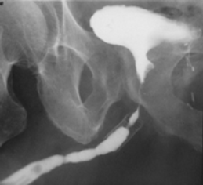
Copyright 2019 Dr Jo Schoeman

