Excision of Urethral Diverticulum – Male

Item Number:

Why is it done?

• Usually an infected peri-urethral gland blocks and becomes infected
• Causes a bulge which interferes with urination
• Can mimic prostate enlargement LUTS
• Usually an MRI of the urethra delineates this beautifully.

. 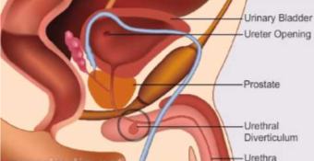

How is it done?

• This procedure is done under a general anaesthetic, as decided by the anaesthetist.
• The legs will be elevated into the lithotomy position.
• This procedure is done both cystoscopically and with an incision over the urethra (Bulbous Spongiosum or Perineum)
• The urethra is evaluated. endoscopically and a catheter placed
• If it is a small urethral diverticulum it can be opened into the urethra endoscopically
• If it has a narrow neck then an external approach:
• The Penis or Perineum will then be incised over the urethrocoele.
• A Fogarty catheter will be placed inside the diverticulum and the balloon inflated to delineate the borders of the diverticulum.
• The diverticulum will be dissected out with injuring adjacent structures.
• The neck will be tied off at the level of the adjoining urethra.
• Dissolvable closure sutures will be placed for hemostasis
• A cystoscopy confirms no injury to the urethra.
• A catheter will be placed until you are awake for some compression.
• Prophylactic antibiotics will be given to prevent infection.

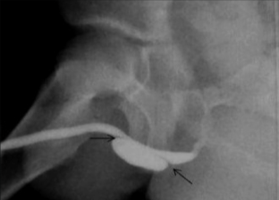
.

Complications

Side–effects

• Any anaesthetic has its risks and the anaesthetist will explain all such risks.
• Complications: hemorrhaging, and urine retention
• Patients catheter will be removed the next morning
• If you cannot urinate after 2-3 attempts, a catheter may be inserted to empty your bladder.
• You may suffer temporary incontinence
• You may suffer permanent incontinence as advised by Jo, depending on the extent of the diverticulum. Make sure you have discussed this with Jo.
• NB! Each person is unique and for this reason symptoms may vary!

Copyright 2019 Dr Jo Schoeman

