Ureteroscopy and Fulgeration Lesion

Item Number:

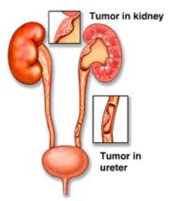

Why is it done?

• Viewing suspicious lesions in upper urinary tracts (ureter and renal pelvis)
• Flexible uretero-renoscopy to review inside of renal pelvis and renal calyces
• Removal of lesion using laser
• Rigid is better for the ureteric inspection

How is it done?

• Patients will receive a general anaesthesia.
• Prophylactic antibiotics is given.
• The correct kidney is identified and marked while you are awake
• You would have had a cystoscopy with retrograde pyelogram 10 days prior with placement of ureteric stent to prepare your ureter
• A cystoscopy will be done first to remove the stent and 2 guidewires will be placed to enable access up the ureter
• Depending on the position of the lesion, either a rigid or flexible uretero-renoscope will be used.
• Suspicious lesions may be biopsied and fulgerated.
• Laser fulgeration or Diathermy may be used.
• Catheters will be removed the next morning depending on the presence of blood in the urine
• Extended use of a ureteric stent may be advised, depending on degree of bleeding

. 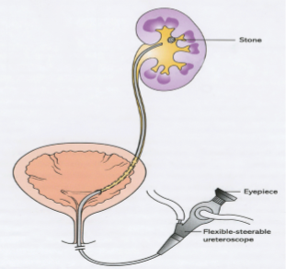

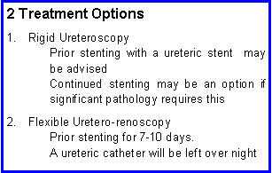

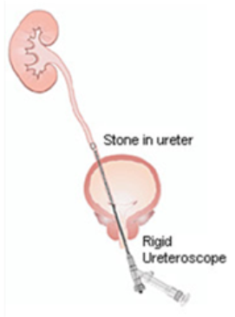
.

Complications

Side–effects

• Ureteric perforation
• Stricturing / Narrowing
• Disruption of ureter
• Stent Irritation
• Procedure abandoned due to bleeding

Copyright 2019 Dr Jo Schoeman

