First Stage
Sacro Neuro Modulation

Item Number: 36663, 18262

The aim is to alter the neuro-transmission from the Spinal Centre to the Bladder

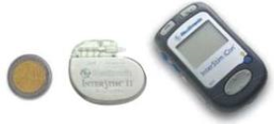

Why is it done?

• To alter the neuro-transmission from the Spinal Centre to the Bladder:
• Refractory Over Active Bladders with Urge Incontinence (OAB)
• Under Active Bladders (UAB)
• Chronic Pelvic Pain
• Faecal Incontinence
• Causative factors:
Undetermined
Neurogenic causes such as Multiple Sclerosis

When at least 2 anticholinergic drugs or B-adrenergic drugs have failed to have provide an improvement in symptoms of OAB
An alternative for ISC or permanent IDC for UAB
The aim was to alter the neuro-transmission from the Spinal Centre to the Bladder
This will be a trial to see if this works for you

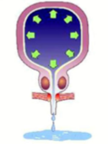

How is it done?

• A sedation is administered
• You will be placed prone (on your stomach) with lower back and buttocks exposed
• A Needle will be placed in the S3 foramina of the sacrum and connected to a electrical current with increased frequency until the correct response is obtained
• Correct response would be puckering of the anal sphincter as well as movement of the big toe
• The lead is then tunneled under the skin
• The Lead is attached to an external modulator and battery .
• Pts with UAB may have permanent lead placement from the start, as effects may take up to 12 months to occur

.
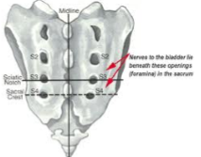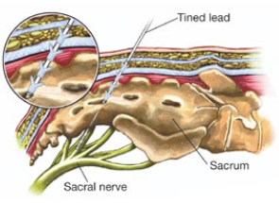

• If you have an OAB: you should experience a marked improvement over the previous 2 weeks
• A minimal requirement of at least 50% improvement in urinary symptoms is 1required to progress to a full implant
• The Temporary leads will be removed with the external module and the permanent leads may be introduced on the next procedure
• As routine in my practice, the permanent lead is used as the temporary, therefore allowing for the exact same results as with the trial period
• The permanent battery will be placed in a pocket created under the skin with extension of prior incision on the subsequent procedure
• Generally a temporary lead is not done for an UAB, as the response may take up to 9-12 months
• Leads for pain are placed bilaterally and in multiple sites

Complications

• Some local discomfort may be experienced.
• Nerve stimulator may provide abnormal sensations, which your body adjusts to.
• A Representative from Medtronic will be in contact with you to check on your settings and responses.
• If after a 2 weeks period of the temporary leads have shown an improved in your bladder, consideration will be given to a permanent implant
• If no response is obtained the leads may be removed.
• NB! Each person is unique and for this reason symptoms may vary!

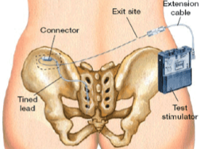

Copyright 2019 Dr Jo Schoeman

