Rectus Sheath / Fascial Sling

Item Number:

Stress Urinary Incontinence

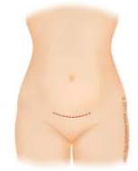

Why is it done?

• Stress incontinence
• A combination of stress incontinence and detrusor over-activity of which DO the lesser
• Involuntary urine leakage with any exertion, coughing or sneezing
• Risk factors
- More than 2 pregnancies, big babies,
complicated deliveries, episiotomy
- Smokers
- Being overweight

• Where Intrinsic Sphincter Deficiency has been proved due to a failed previous sling

• Failed previous incontinence procedures

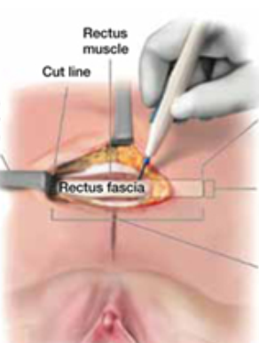

How is it done?

• This procedure is done under a spinal / general anaesthetic, as decided by the anaesthetist.
• The legs will be elevated into the lithotomy position.
• A 10cm horizontal incision is made above the pubic bone.
• A 10-15cm X 5cm strip of rectus sheath fascia is harvested and prepared with 2 Prolene or Nylon arms
• A small incision is made in the vagina.
• The sling is placed behind the pubic bone and brought to the skin above the pubic bone, through the incision.
• The sling is placed with some tension.
• The bladder will be inspected with a Cystoscopy to exclude any injuries to the bladder wall.
• The wounds are closed with dissolvable sutures and/or skin glue.
• A local anaesthetic is given for pain relief.
• A urinary catheter is placed for 24hrs.
• A vaginal plug will also be placed.
• The catheter and plug will be removed early the next morning.
• The patient’s urine output will be measured each time they urinate and the residual will be measured. (Patients will be required to do this up to 3 times.)
• If the residual amount of urine is more than 1/3 of the total bladder capacity, the patient may have to self-catheterize, until the residual volume is acceptable.
• Prophylactic antibiotics will be given to prevent infection.

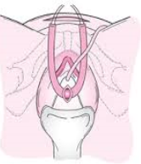

Complications

• Patients will have a trial of void without catheter the next day.
• Patients will be discharged as soon as they can completely empty the bladder.
• Patients may be required to self-catheterize for a week or two.
• The sling may be loosened if placed too tight, requiring going back to the operating room.
• Patients may initially suffer from urge incontinence but this will improve within the next 6 weeks.
• Allow 6 weeks for symptoms to stabilise.
• May also have abdominal pain with coughing and sneezing due to tension on rectus muscle
• There may be some blood in the urine. This can be remedied by drinking plenty of fluids until it clears.

Copyright 2019 Dr Jo Schoeman

