Prostatic Stent

Item Number:

Minimal invasive management for the relief of LUTS (lower urinary tract symptoms) or Urinary Retention

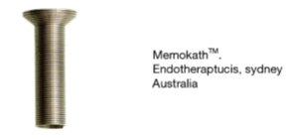

Why is it done?

• This procedure is performed when the prostate gland is causing LUTS and you want an alternative to long anaesthetic procedures
• Symptoms include: a weak stream, nightly urination, frequent urination, inability to urinate, (LUTS) and Urinary Retention
• This is alternative to an invasive procedure where long periods of anaesthetic is contra-indicated.
• Usually for chronically sick patients who cannot undergo surgery, yet are active enough not to want a permanent catheter.
• Usually a trial of alpha blockers would been attempted and Step-up Therapy with 5 Alpha Reductase Inhibitors have been unsuccessful
• Any prostate size

How is it done?

• Patients will receive a sedation with local anaesthetic gel placed in the urethra.
• A cystoscopy is performed by placing a camera in the urethra with the help of a lubricant jelly and an irrigant fluid.
• The measurements of the prostatic urethra is taken (length)
• Appropriate length coil is chosen.
• The device is placed through the cystoscopic sheath, to sit snug in the prostate urethra stretching from the bladder neck to the apex of the prostate
• Prophylactic antibiotics will be given to prevent any infections.

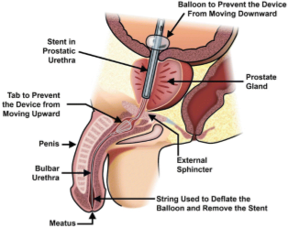

Complications

• Retrograde Ejaculation
• Possibility of Infertility due to retrograde ejaculation,
• Stress incontinence especially in the elderly and the diabetic patients
• Urgency and urge Incontinence especially until Detrusor Hyperactivity dissipates
• Urge symptoms may persist due to detrusor fibrosis caused by long term bladder outlet obstruction
• May experience a slower stream initially due to swelling
• Possible infection due to cystoscopy (<2%)
• Migration of device into bladder, requiring a procedure to retrieve this.
• Long term yields the risk for encrustation and recurrent infections
• NB! Each person is unique and for this reason symptoms vary!

.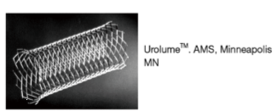

Copyright 2019 Dr Jo Schoeman

