Laparoscopic Simple Nephrectomy

Item Number: 36519

Why is it done?

• A symptomatic non-functioning kidney
• Pyonephrosis
• Infection
• Causing discomfort
• Risk for post-operative dialysis will have been discussed prior to your surgery by means a referral; to a Nephrologist.
Very Important!!
The correct side for surgery should be checked : CT scan present
Your approval Prior to anaesthesia being commenced

How is it done?

• Patients will receive a general anaesthesia, unless contra-indicated.
• Prophylactic anti-biotics is given.
• An indwelling catheter is placed.
• The correct kidney is identified and marked while you are awake
• Depending on the side of non-functioning kidney 3-4 incisions will be made: 1 for the hand-port of approximately 8cm depending on the amount of sub-cutaneous fat present
1 for the camera-port
1 for the working-port
(1 for the liver retractor on the right)
• The colon is reflected to reveal the retro-peritoneal space
• The ureter is identified and cleared up to the hilum
• The arteries are identified and tied off and cut first. More than 1 can be present
• Then the vein/ veins are tied and cut.
The rest of the kidney is mobilized with its surrounding fat and removed

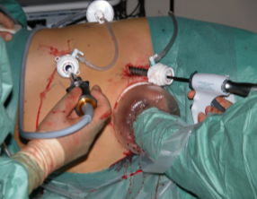

.

Complications

Side–effects

• Minimal Blood loss
• Wound Infection.
• Post-operative hernia formations especially associated in the elderly with atrophic abdominal muscles
• Prolonged hospital stay due to impaired renal function recovery.
• Dialysis as discussed by your Nephrologist, if pre-operatively indicated
NB! Each person is unique and for this reason symptoms vary

Copyright 2019 Dr Jo Schoeman

