Intravesical BCG-Therapy

Item Number:

Why is it done?

• Treatment for localized superficial Urothelial Carcinoma of Bladder and Ureter (T1G3)

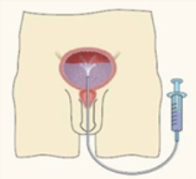

How is it done?

• A Local anaesthetic gel is administered as for a Urethral Catheterization procedure
• This is done under sterile procedure.
• A 14-16 Fr Indwelling Catheter is placed into your bladder.
• The BCG is installed using strict administering criteria
• Usually 1 vial of BCG is mixed with Saline to a 50cc volume
• The catheter is then removed
• The BCG is required to stay in your bladder for 2 hours.
• Body rotation every 30 minutes allows optimal contact of urothelial Surfaces to the BCG.
• WARNING: Any Fevers require urgent attention
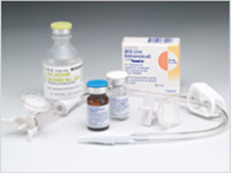
What next?

• This will be done every week for 6 weeks
• 6 weeks after this a check Flexible Cystoscopy will be scheduled as part of your surveillance protocol for your Urothelial carcinoma
• A Further 2 Installations will be arranged in the following 3 months as part of a Maintenance Protocol
• This may be repeated.

Complications

Side–effects

• Some local discomfort may be experienced.
• Your voiding nature will change within the next week
• You may experience some urinary frequency
• You could developed a fever requiring urgent attention.
• Systemic effects of BCG would be fever
• Delayed effects would a urinary tract infection
• The possibility of Miliary Tuberculosis
• NB! Each person is unique and for this reason symptoms may vary!
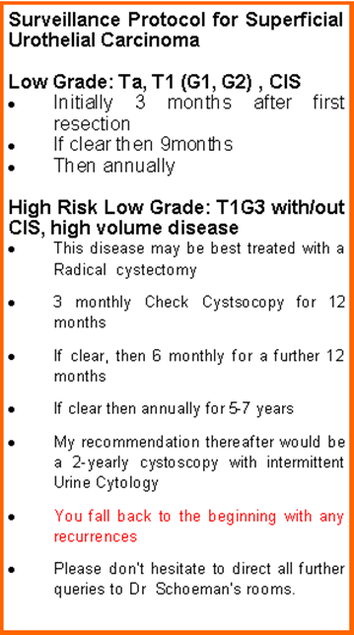
Copyright 2019 Dr Jo Schoeman

