Indwelling Urethral Catheter

Item Number: 36800

Non-invasive placement of an a silicone tube which is secured inside the bladder and attached to a drainage bag on the outside, in order to drain an obstructed bladder – Urine Retention

Why is it done?

• This can be placed as an emergency for patients in acute urinary retention
Prostate obstruction
Urethral strictures
Blood clot obstruction caused by bleeding
Hematuria (bleeding)
Severe urinary tract infections
• Commonly placed intra-operatively for long, non-urological surgical procedures to enable urine drainage and monitoring urine output.
• Commonly placed at the end of a Urological procedure to enable urine drainage and to enable hemostatsis (stopping bleeding)

How is it done?

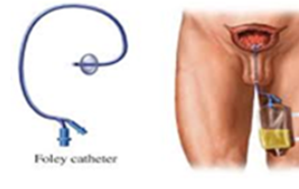

• This is done as a sterile procedure, therefore the genital area will be cleaned with a non-abrasive dis-infectant.
• A sterile catheter will be used
• Local anaesthetic gel is placed in the urethra a few minutes prior to the placement of the catheter. This may initially sting for a few seconds until it numbs the mucosa.
• An appropriate size catheter (14-18Fr) will be inserted
• Urine should be aspirated with a syringe to confirm a correct position in the bladder.
• An anchoring balloon will be inflated with 10cc of sterile water.
• A drainage urine bag will be attached
• The catheter will be secured to your leg. (check that this is always secured)

.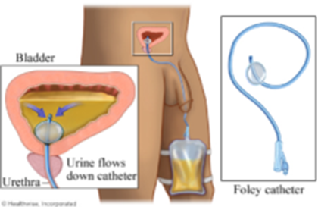

Complications

• Urethra with resulting discomfort.
• In the presence of a urethral stricture, it may be impossible to pass the catheter, and a flexible cystoscopy with dilatation of the stricture may be required prior to placement.
• If you had a large over-stretched bladder (urine retention) you may experience bleeding as the bladder empties, caused by the mucosal tears that have occurred.
• Catheters that have been placed long term, may cause irritation and possibly attract infection. Permanent catheters are usually changed every 6-8 weeks.

.
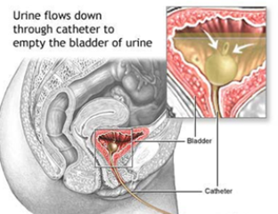

Copyright 2019 Dr Jo Schoeman

