Bladder fistulectomy

Item Number:

Why is it done?

• Bladder intestinal fistula is an abnormal communication between bladder and bowel.
• Many causes:
Previous surgery
Diverticular disease
Colonic cancers
Radiation
• This procedure is performed when all other treatment options are exhausted with recurrent symptoms and persistent Pnematuria and fecaluria due to a colonic-vesical fistula
• Symptoms include: Pneumaturia (air in urine), Faecaluria (stool in Urine, recurrent bladder infections.
• This surgery is usually done with a Colo-rectal surgeon and may involve a partial bowel resection, possibly a temporary loop ileo/colostomy (diversion of bowel with an external bag)

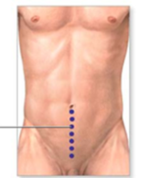

How is it done?

• Patients will receive a general anaesthesia, unless contra-indicated.
• Prophylactic anti-biotics is given.
• An indwelling catheter is placed and the bladder is filled with saline.
• A lower midline incision is made.
• The retropubic space of Retzuis is entered
• The bladder is resected away from the bowel.
• The affected piece of bowel may be resected with either a temporaru diversion of bowel to a bag, or a primary anastomosis depending on the colo-rectal surgeons findings
• The affected part of the bladder may be resected. Bladder is closed in 2 layers over a 3 way irrigation catheter
• Omentum will be placed between bladder and bowel where at all possible to limit recurrences
• A drain is left for a couple of days
• You may have continuous Antibiotics over the next few days.
• You have a few days stay in ICU or high care facility

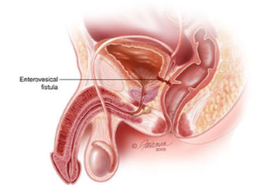

Complications

Side–effects

• Rarely blood loss requiring blood transfusion.
• Infection/ sepsis
• Prolonged hospital stay.
• Urine leak requiring prolonged catheterisation.
• Bowel leak etc
• NB! Each person is unique and for this reason symptoms vary!. 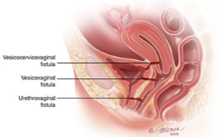
Copyright 2019 Dr Jo Schoeman

