Augmentation Bladder - Ileocystoplasty

Item Number:

Why is it done?

• This procedure is seldomly used today, with the more frequent use of Sacro-neuro-modulation and Intravesical BOTOX
• This procedure is done to enlarge a bladder, especially in the spinal patient with a small contracted overactive bladder.
• It can also be done as last resort in small overactive bladder after all other medical options have failed.

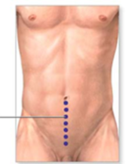

How is it done?

• A General anaesthetic will be given
• You would have had bowel preparation for 3 days prior to surgery.
• A sterile surgical field is prepared
• Prophylactic antibiotics are given.
• An indwelling catheter is inserted and the bladder is then distended with fluid (saline).
• A lower abdominal incision is made, splitting the linea alba.
• A 15-20cm segment of the terminal ileum is isolated and removed from the rest of the intestinal tract on its vascular pedicle.
• A watertight anastomosis of the bowel ends are done, and tested.
• The bladder is then bi-valved.
• The 15cm of ileum is opened on the anti-mesenteric edge and the bowel in cleaned.
• The ileum-segment is then sewn on to the bi-valved bladder.
• A 3-way catheter is placed
• A drain is left.
• The abdomen and skin is closed
• A catheter will be left for 2 weeks

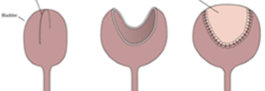

Complications

Side–effects

• Rarely blood loss requiring blood transfusion.
• Infection, Peritonitis.
• Faecal leak from small bowel anastomosis
• Prolonged hospital stay.
• Urine leak requiring prolonged catheterisation,.
• NB! Each person is unique and for this reason symptoms vary!

.

What next?
• You will spend up to 5-7 nights in hospital.
• You will have a catheter for 14 days.
• A drain for 2-3 days.
• You will be discharged as soon as you are drain free, temperature free and have opened your bowels.
• You may initially suffer from urge symptoms caused by the catheter.
• There may be some blood in your urine. You can remedy this by drinking plenty of fluids until it clears.
• A ward prescription will be issued on your discharge, for your own collection at any pharmacy
• A follow-up appointment will be scheduled for 2 weeks for a cystogram.
• Should the cystogram confirm to urine leaks, your catheter will be removed.
• A review appointment is scheduled 6 weeks later
• Don’t hesitate to ask Jo if you have any queries
• DON’T SUFFER IN SILENCE, OR YOU WILL SUFFER ALONE!

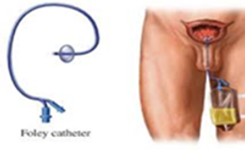
Copyright 2019 Dr Jo Schoeman

