ATOMS Male Sphincter

Item Number: 37381, 37387, 36812

Why is it done?

• Male Stress incontinence/ Incontinence
• Usually after a TURP/TUVP, Radical Prostatectomy in 2% of cases as pre-described complication of surgery

Pre-requirements
• An informed consent is required from the patient and a pre-admission clinic will be arranged.
• Patients may not eat or drink from midnight the previous evening.
• Patients are to refrain from smoking before the procedure.
• Patients allergic to IODINE/CHLORHEXIDINE should clearly state this at the pre-admission clinic as well as to theatre staff and Dr Schoeman.
• Any anti-coagulants such as Warfarin or Aspirin must be stopped 7 days prior to surgery. This may be replaced by once daily Clexane injections.
• Pre-operative blood tests are required 4 days prior to surgery.
• Patients with cardiac illnesses require a cardiologist/ physician report.
• A chest X-ray is required for patients with lung disease.
• Be prepared for a 2 night stay.

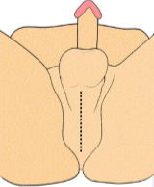

How is it done?

• Anaesthetic, as decided by the anaesthetist.
• The legs will be elevated into the lithotomy position.
• A 7cm incision is made on the perineum (space between scrotum and anus).
• The silicone inflatable cushion is placed anterior to the upper end of the corpora cavernosa of the penis.
• The arms of the device are curled around the inferior rami of the pubic bone.
• The device is placed with pressure on the CC
• This tensioning can be done under cystoscopic vision.
• The access port is placed in the scrotum
• The pad is inflated with carefully determined volume
• The wounds are closed with dissolvable sutures and/or skin glue.
• A local anaesthetic is given for pain relief.
• A urinary catheter is placed for 24hrs.
• The catheter will be removed early the next morning.
• The patient’s urine output will be measured each time they urinate and the residual will be measured. (Patients will be required to do this up to 3 times.)
• If the residual amount of urine is more than 1/3 of the total bladder capacity, the patient may have to self-catheterize, until the residual volume is acceptable.
• Prophylactic antibiotics will be given to prevent infection.

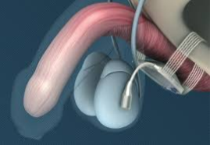

Complications

• Any anaesthetic has its risks and the anaesthetist will explain all such risks.
• Complications: hemorrhaging, requiring blood transfusion <1%;
• Patients will wake up with a catheter in the urethra and bladder. This will remain in the bladder for 24 hrs.
• Pelvic pain for 10-14 days may occur, making it difficult to sit.
• If you cannot urinate after 2-3 attempts, the catheter may be replaced and adjustment to sphincter volume will be made
• This may less effective in irradiated patients
• NB! Each person is unique and for this reason symptoms may vary!

.
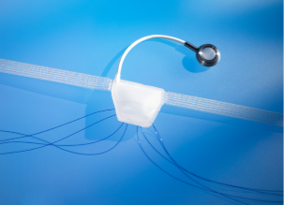

What next?
• Patients will have a trial of void without catheter the next day.
• Patients will be discharged as soon as they can completely empty the bladder.
• Adjustments to sphincter pad volumes will be made in 6 weeks.
• Patients may initially suffer from urge incontinence but this will improve within the next 6 weeks.
• Allow 6 weeks for symptoms to stabilise.
• Initial period of pelvic pain is expected.

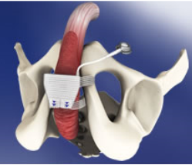
Copyright 2019 Dr Jo Schoeman

